- Tên và phân loại:

- Mục đích, ý nghĩa:
Provide a surrogate or placeholder for another object to control
access to it
- Động lực sử dụng:
- A proxy is
• A person authorized to act for another person
• An agent or substitute
• The authority to act for another
- There are situations in which a client does not or can not reference an
object directly, but wants to still interact with the object
- A proxy object can act as the intermediary between the client and
the target object
- The proxy object has the same interface as the target object
- The proxy holds a reference to the target object and can forward
requests to the target as required (delegation)
- In effect, the proxy object has the authority the act on behalf of the
client to interact with the target object
- Khi nào sử dụng:
- A remote proxy provides a local representative for an object in
a different address space
- A virtual proxy creates expensive objects on demand
- A protection proxy controls access to the original object.
Protection proxies are useful when objects should have
different access rights

- Cấu trúc
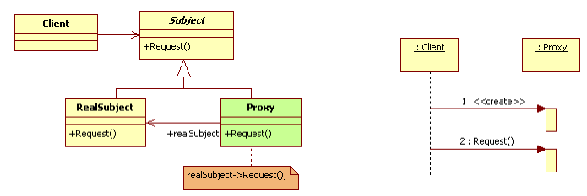

- Các thành viên - Sự cộng tác
- Subject: defines the common interface for RealSubject and
Proxy so that a Proxy can be used anywhere a RealSubject is
expected
- RealSubject: defines the real object that the proxy represents
- Proxy
• Maintains a reference that lets the proxy access the real subject.
Proxy may refer to a Subject if the RealSubject and Subject
interfaces are the same
• Provides an interface identical to Subject's so that a proxy can by
substituted for the real subject
• Controls access to the real subject and may be responsible for
creating and deleting it
• Other responsibilities depend on the kind of proxy:
- Remote Proxy: responsible for encoding a request and its arguments
and for sending the encoded request to the real subject in a different address space.
- Virtual Proxy: may cache additional information about the real
subject so that it can postpone accessing it
- Protection Proxy: check that the caller has the access permissions
required to perform a request

- Các hệ quả mang lại:
- Introduces a level of indirection when accessing an object.
The additional indirection has many uses, depending on the
kind of proxy:
• A remote proxy can hide the fact that an object resides in a
different address space
• A virtual proxy can perform optimizations such as creating an
object on demand
• Both protection proxies and smart references allow additional
housekeeping tasks when an object is accessed
- Chú ý liên quan đến cài đặt:

- Hệ thống thực tế

- Mẫu liên quan
- Adapter: An adapter provides a different interface to the
object it adapts. In contrast, a proxy provides the same
interface as its subject. However, a proxy used for access
protection might refuse to perform an operation that the
subject will perform, so its interface may be effectively a subset
of the subject's
- Decorator: Although decorators can have similar
implementations as proxies, decorators have a different
purpose. A decorator adds one or more responsibilities to an
object, whereas a proxy controls access to an object

